Information System Analysis & Design (BIS226E)

Smart Village-2024/2025-Spring term

Dr. Nancy Rizk – Ta. Ahmed Abdel Sadek

Student Names and id
1. Abdulrahman Mohamed Ali : 231027096
2. Omar Ibrahim Ahmed : 222007591
3. Youssef Haytham Hatem : 231004456
4. Youssef Mohamed khair : 231017780
5. Mohamed Hany Mohamed : 231027517

smart mall car searching & parking mangment system

Table of content

1. Introduction (Company Overview)
2.1. Business Problem
2.2. Scope
2.3. Objectives
2.4. System Development Methodology
2.5. Feasibility Study
3.1. Detailed explanation of the used data gathering techniques ( at least 3 techniques- 2 obtrusive and one unobtrusive)
3.2. Detailed description of the current (old) system
4.1. Functional Requirements
4.2. Non-Functional Requirements
4.3. Detailed description of the new system
5.1. Data Flow Diagram (DFD) (Context level and Level 0, and at least one process in level 1)
5.2. Use Case Diagram
5.3. Use Case Specification
5.4. Activity Diagram
5.5. Sequence Diagram
5.6. Entity Relationship Diagram (ERD)
5.7. Class Diagram
6.1. Design input and output
6.2. Design database and data dictionary

1. Introduction (Company Overview)
Large mall parking lots can be overwhelming, especially during peak hours. Many visitors struggle to find available spots, and some even forget where they parked. This leads to frustration, wasted time, and inefficient use of space.
Our proposed system uses AI, IOT sensors, and a mobile app to solve this problem. It allows users to easily locate available parking, reserve spots, and—importantly—find their parked vehicle using license plate recognition. The system offers real-time updates, guided navigation, and vehicle tracking through a convenient interface.

2.1. Business Problem
Common parking challenges include:
• Difficulty in finding empty parking spots
• Drivers forgetting where they parked
• No centralized system for real-time updates
• Congested parking zones due to poor flow control
How Our System Solves these:
• Real-time detection of available spots via sensors
• Vehicle location tracking using license plate input
• In-app navigation to guide drivers to their car
• Improved traffic flow and customer satisfaction

2.2. Scope
What the System Covers:
✔ Real-time parking availability using IOT sensors
✔ Mobile app and digital screens to display open spots
✔ Guided navigation to available or reserved spaces
✔ License plate-based car locating system
✔ Spot reservation for registered users
✔ Integration with mall entry/exit systems
✔ Analytics for mall management
What the System Does NOT Cover:
✖ External parking areas not fitted with sensors
✖ Vehicles not entered into the system
✖ Responsibility for vehicle security or personal belongings

2.3. Objectives
Reduce Parking Time – Let drivers find and access empty spots faster
Find Lost Vehicles – Allow users to locate their parked cars by entering their license plate number in the app or at kiosks
Improve Visitor Experience – Make mall visits stress-free from arrival to departure
Maximize Parking Efficiency – Increase space turnover through smart allocation
Enable Smart Analytic – Provide management with real-time data for improvements

2.4. System Development Methodology
Advantages:
Early Detection of Issues: Errors or gaps in user requirements are identified in early phases.
Customer Feedback Integration: Regular user feedback is collected, improving the system after every iteration.
Flexibility: Changes can be made between iterations without redesigning the whole system.
Progress Visibility: Functional versions of the system are delivered early, giving stakeholders visibility of progress.

Reduced Risks: Smaller parts are easier to manage and debug, reducing overall development risk.
Disadvantages:
Scope Creep: Constant feedback and change requests can lead to uncontrolled changes.
Incomplete Requirements: Final system structure may not be clear from the start.
Integration Overhead: Combining new increments with existing ones can be complex and time-consuming.
Resource Intensive: Frequent changes may increase development cost and time.

3.1. Detailed explanation of the used data gathering techniques ( at least 3 techniques- 2 obtrusive and one unobtrusive)
Interview Technique
Objective:
To collect in-depth qualitative data from different user types to understand their pain points, expectations, and how they interact with current parking systems.
Participants:
2 Mall Visitors
1 Parking Lot Attendant
1 Mall IT Manager
Interview Format:
Type: Semi-structured (open-ended core questions + room for follow-ups)
Method: In-person
Duration: 20–30 minutes per participant
Tools: Audio recorder, note-taking, interview guide
Sample Questions:
For Mall Visitors:
How often do you visit this mall?
What challenges do you face when parking your car?
Have you ever forgotten where you parked? If yes, how did you handle it?
What features would you like in a parking app?
For Parking Attendant:
What issues do drivers complain about the most?
How do you currently track open/occupied parking spaces?
Do you see areas of the parking lot that are consistently underused or overused?
For Mall IT Manager:
Are there any current systems in place for managing parking?
What is the budget range for smart technology upgrades?
What KPIs do you use to evaluate parking efficiency?
Findings Summary:
Visitors want real-time guidance and car-locating features.
Staff need a centralized dashboard to monitor occupancy.
Management is interested in analytics and visitor behavior trends.
2. Questionnaire Technique
Objective:
To gather quantitative data from a broader user base about parking behavior and preferences.
Target Group:
50 mall visitors (random sampling across different age groups and visit frequencies)
Distribution Method:
Google Forms + paper forms placed at mall entrances and parking booths
Structure:
Type: Closed-ended (Likert scale, multiple choice) and a few open-ended questions
Estimated Time: 5–7 minutes to complete
Sample Questions:
Section A: Demographics
How often do you visit this mall? (Daily / Weekly / Monthly / Rarely)
What is your age group? (Under 20 / 21–30 / 31–50 / Over 50)
Section B: Parking Behavior
How long do you usually spend looking for a parking spot? (0–5 min / 5–10 min / 10+ min)
Have you ever forgotten where you parked your car? (Yes / No)
Section C: Technology Acceptance
Would you use an app to help you find and reserve parking? (Definitely / Maybe / No)
How important is real-time parking availability to you? (1 = Not Important, 5 = Very Important)
Section D: Suggestions
What feature would you most like in a smart parking app? (Open-ended)
Results Summary (Sample Highlights):
80% of participants spend more than 5 minutes finding parking.
65% have forgotten their parking location at least once.
90% are open to using a mobile app for guidance and reservations.
Top requested feature: “Find My Car” using license plate input.
Conclusion:
These two techniques revealed clear needs:
Visitors want fast, guided parking and car location help.
Staff and management want centralization and data analytics.
There is a strong demand for a user-friendly app and smart sensor integration, confirming the proposed system’s relevance and feasibility.
Name
*
How often do you visit shopping malls?
Never
Unlikely
Often
Every Week
Everyday
How difficult do you find it to park in malls?
Very Difficult
Difficult
Alright
Easy
Very Easy
Have you ever forgotten where you parked your car?
Yes
No
Would you use an app that shows real-time available parking spots?
Yes
No
How useful would a car locator feature (using license plate) be?
Vey Useful
Useful
Not really
Not Useful
How likely are you to reserve a parking spot before arriving? (1 being least likely 5 being most likely)
1
2
3
4
5
What features would you like in such a system? (Paragraph)
*
Any concerns or suggestions for improvement? (Paragraph)
*
Other thoughts or comments
*

3.2. Detailed Description of the Current (Old) System
The current mall parking system is largely manual and unstructured:
No real-time data on parking availability.
Visitors must drive around to find a spot, often taking over 10 minutes during busy hours.
No system exists to locate parked vehicles if users forget their location.
No reservation system is available—parking is entirely first-come, first-served.
Parking attendants manually report spot availability, which is unreliable.
Mall management lacks data analytics on usage patterns, peak hours, or occupancy rates.

4.1. Functional Requirements
The system shall allow users to search for available parking spots in real time.
The system shall allow users to reserve a parking spot via the mobile app.
The system shall generate a QR code upon successful booking.
The system shall allow users to enter and exit by scanning the QR code.
The system shall track vehicle location using license plate recognition.
The system shall help users find their parked car using license plate input.
The system shall allow admins to view analytics on occupancy and usage.
The system shall notify users if their reserved spot is about to expire.

4.2. Non-Functional Requirements
Performance: The system must update parking availability data every 10 seconds.
Availability: The system shall be available 99.9% of the time.
Scalability: The system must support up to 10,000 users simultaneously.
Security: Data must be encrypted and protected from unauthorized access.
Usability: The mobile app interface must be user-friendly and intuitive
Reliability: The system should accurately locate vehicles 95% of the time.
Compatibility: The system must work on Android and iOS devices.

4.3. Detailed Description of the New System
The new Smart Mall Car Searching & Parking Management System introduces automation and user-friendly technology:
IoT Sensors track real-time availability of each parking spot.
Mobile App shows available spots, allows reservations, and provides turn-by-turn guidance.
Users can search for their car by entering their license plate—useful if they forget where they parked.
QR codes allow users to enter and exit the parking using booked spots.
Cameras with license plate recognition (LPR) enhance security and vehicle tracking.
Admins can view dashboards showing occupancy, trends, and system performance.
Digital kiosks inside the mall also allow visitors to locate their car by typing in the license plate.

5.1. Data Flow Diagram (DFD) (Context level and Level 0, and at least one process in level 1)
DFD Context Level
Entities:
Customer: interacts with the app
Admin System: manages analytics
Sensor System: sends spot status
License Plate Camera: confirms vehicle identity
Processes:
Smart mall Car Parking System
Data Flows:
From customer: Search request, reservation, license plate input.
To customer: Available spots, QR code, car location
From sensors: Spot availability
From license plate system: Plate info
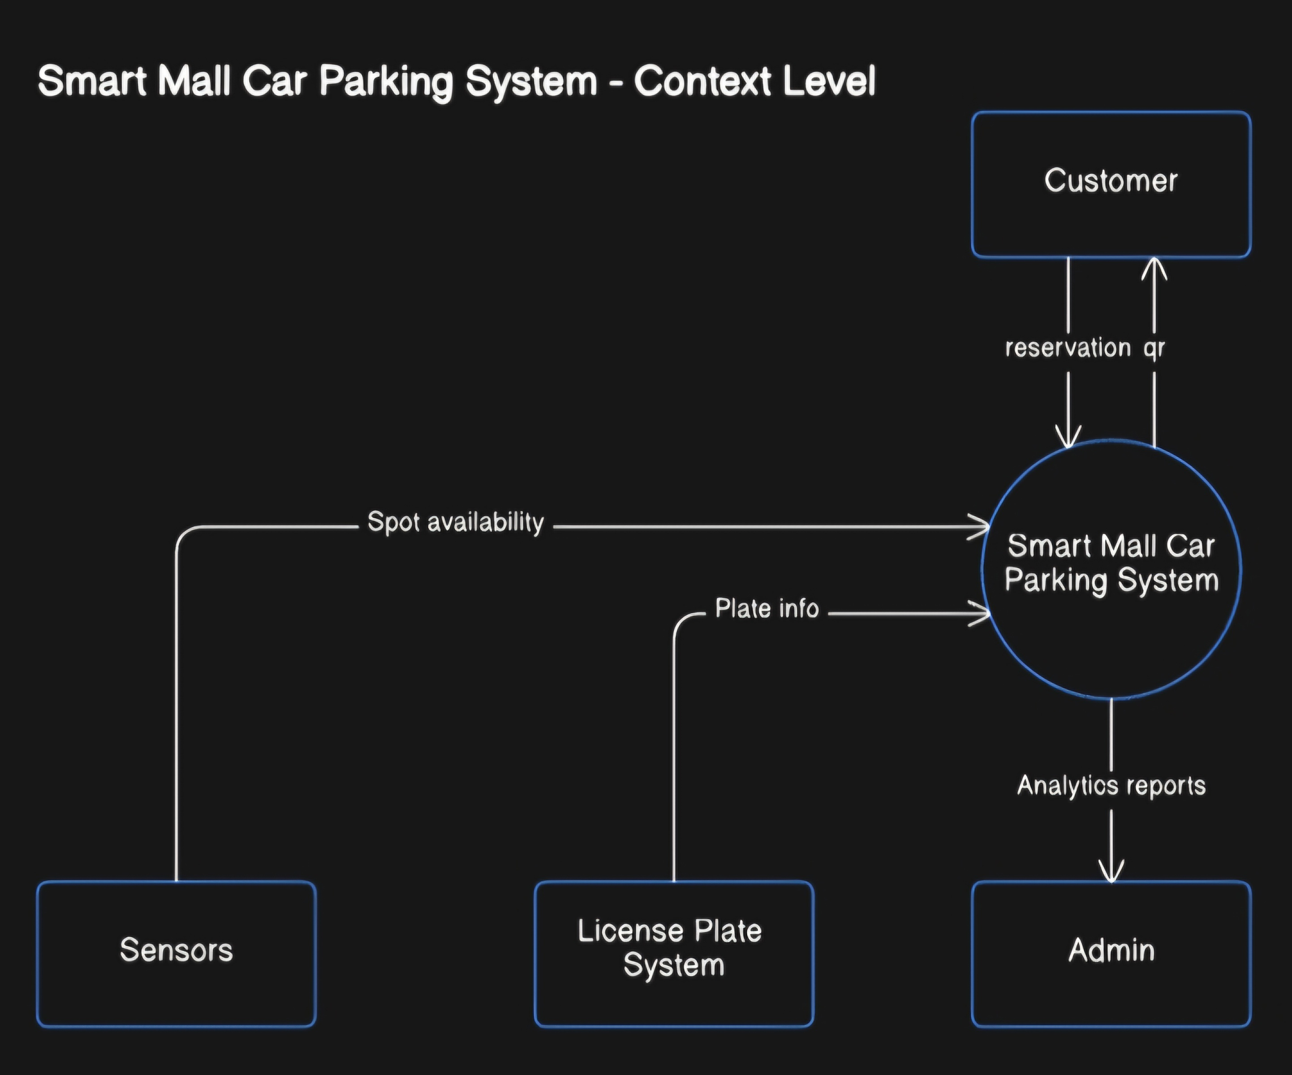
To admin: Analytics reports
DFD – Level 0
Main Processes:
- Search and Reserve Spot
2.0 Vehicle Entry/Exit Validation
3.0 Car Location Assistance
4.0 Admin Analytics Dashboard
Data Stores:
D1: Spot Database
D2: User Reservation Records
D3: License Plate Log
Data Flows:
Customer → 1.0
Search Request
Reservation Request
- → Customer
Available Spots
QR Code
1.0→ D1
Update Spot Availability
1.0→ D2
Store Reservation
Sensor System → 1.0
Spot Availability Data
Customer → 2.0
QR Code Scan
2.0 → D2
Validate Reservation
License Plate Camera → 2.0
Vehicle Plate Info (for entry/exit validation)
Customer → 3.0
License Plate Input (to locate car)
3.0 → D3
Retrieve Vehicle Location
License Plate Camera → 3.0
Vehicle Plate Info (to assist in locating car)
4.0 → Admin System
Analytics Reports
D1/D2/D3 → 4.0
Parking Data
Reservation Logs
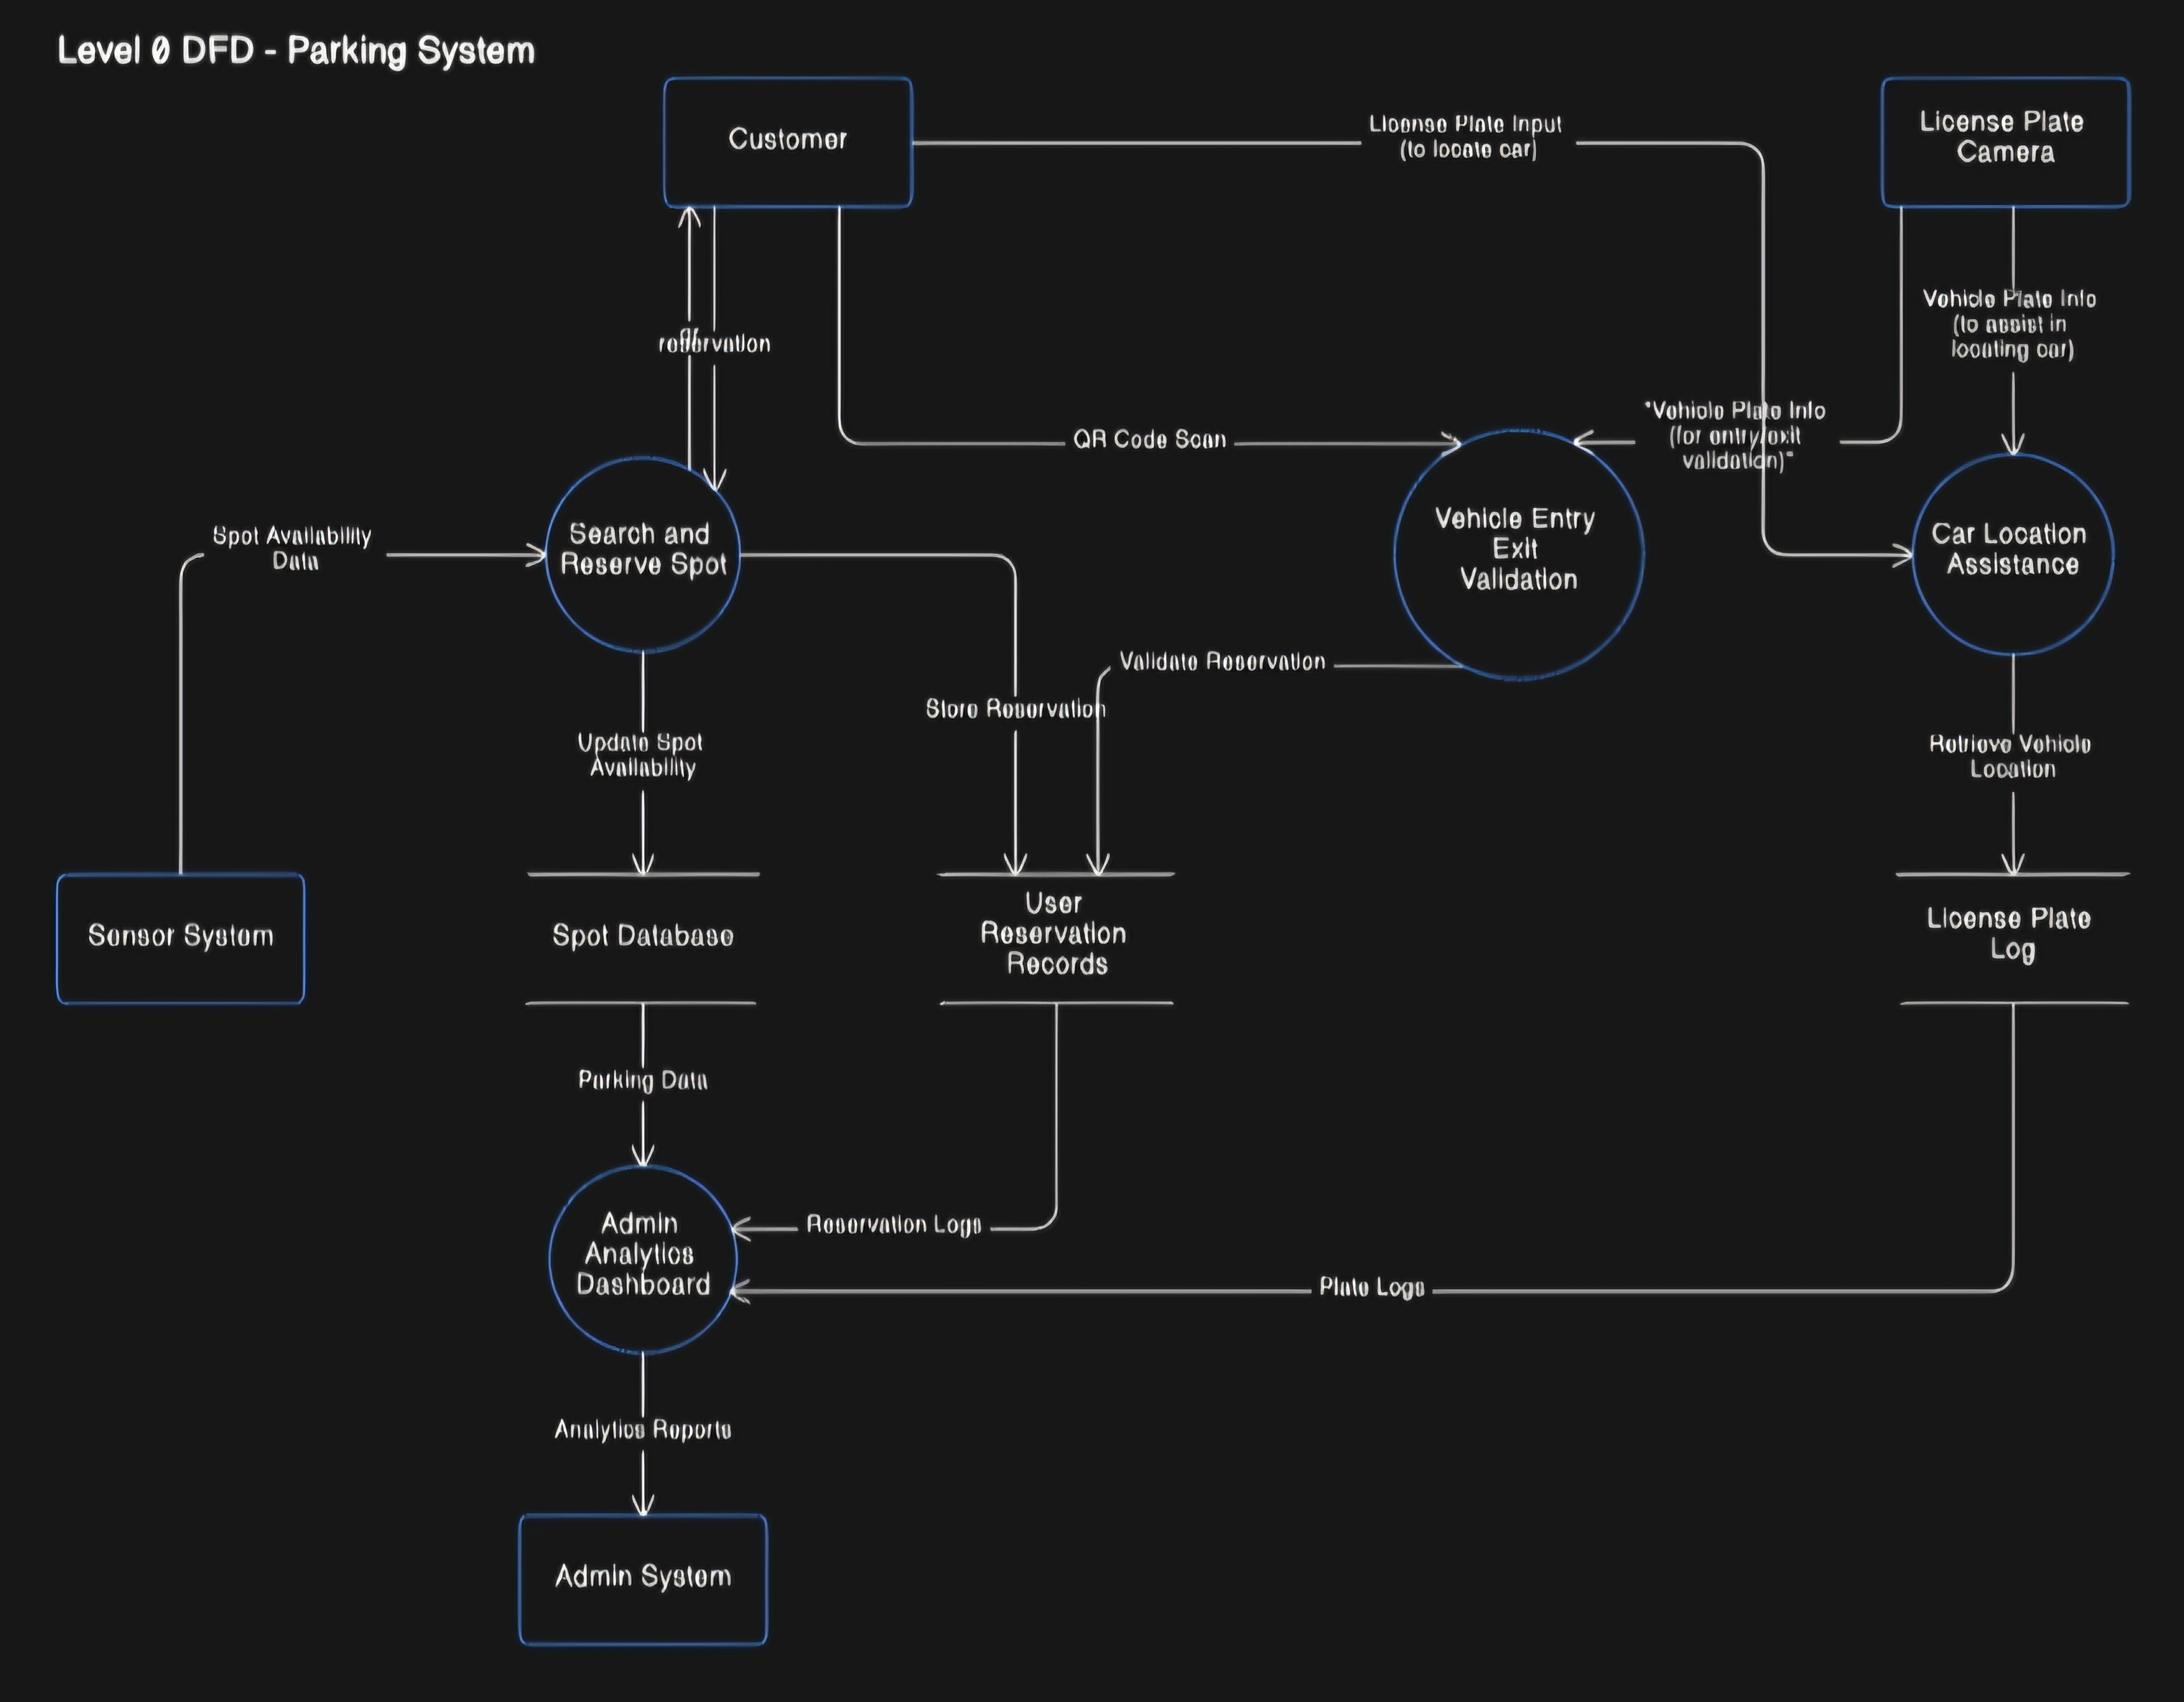
Plate Logs
Data flow diagram first process in level 1
Main Processes:
1.1 Receive Search Request
1.2 Check Spot Availability
1.3 Show Available Spots to User
1.4 Receive Reservation Request
1.5 Store Reservation & Generate QR Code
Data Flows:
Customer → 1.1: Search Request
1.2 ← Sensor System: Spot Availability
1.2 → 1.3: Available Spots
1.3 → Customer: Available Spots Display
Customer → 1.4: Reservation Request
1.4 → 1.5: Reservation Data
1.5 → D1: Update Spot Availability
1.5 → D2: Store Reservation
1.5 → Customer: QR Code
Data Stores Used:
D1 – Spot Database (used in checking and updating availability)
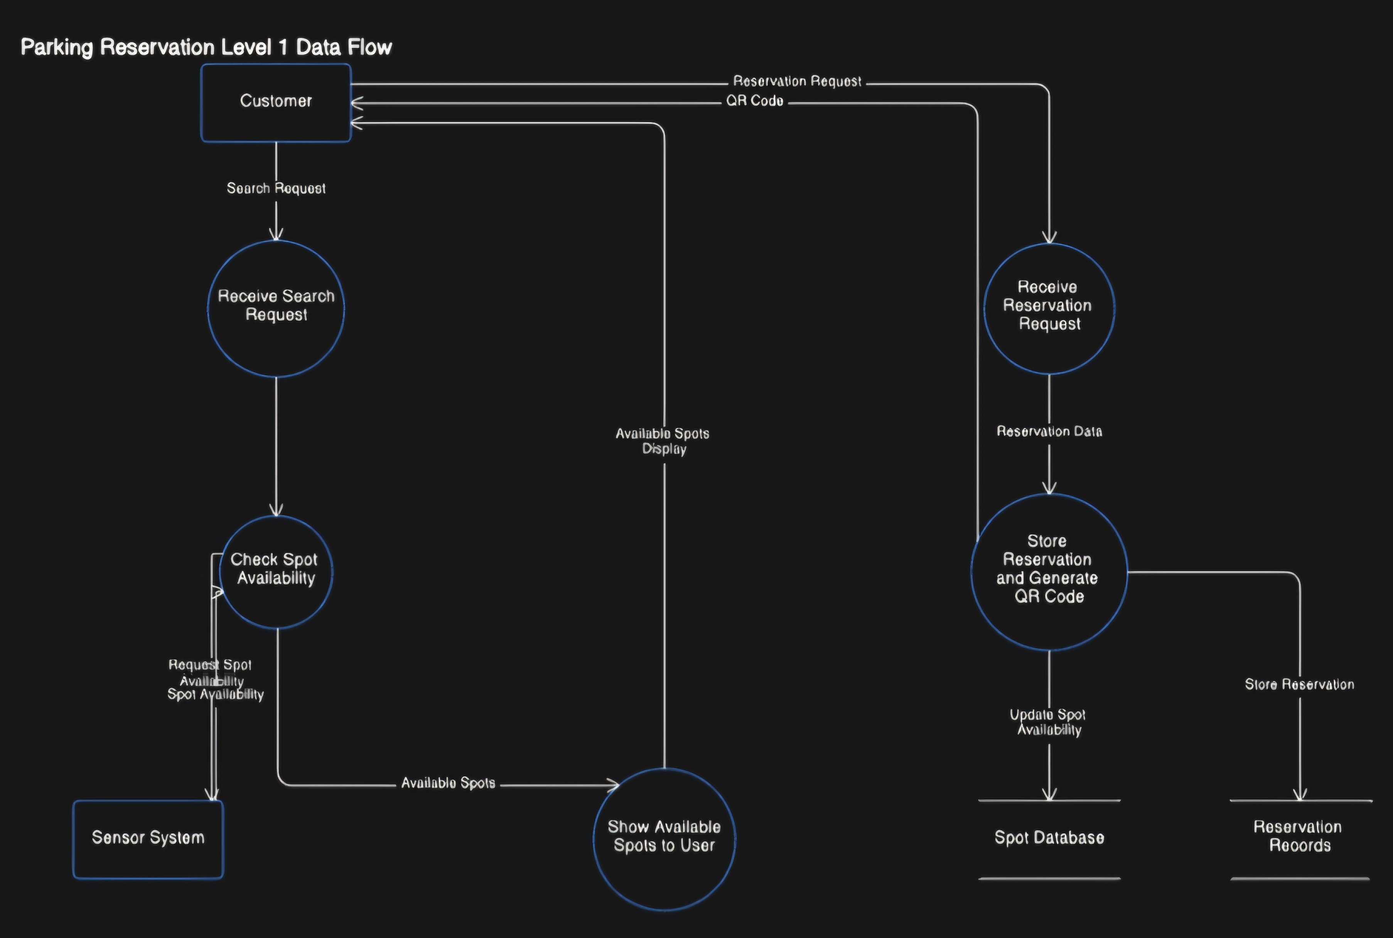
D2 – Reservation Records (used to store new reservations)

5.2. Use Case diagram
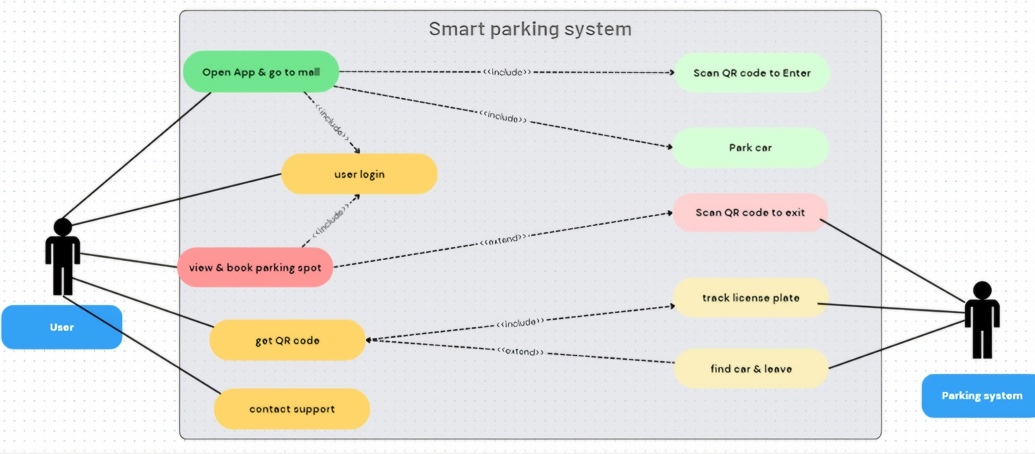

5.3. Use Case Specification
1. The user opens the app when they are near or inside the mall.
2. The user picks a spot and books it using the app.
3. The app creates a QR code for the booked spot.
4. At the parking entrance, the user scans the QR code to enter.
5. The user parks the car in the booked spot.
6. When they want to leave, the user scans the QR code again at the exit.
7. A camera tracks the license plate to check the car.
8. The app can also help the user find their car if they forgot where it’s parked.
9. Finally, the user gets the car and exits the parking lot.

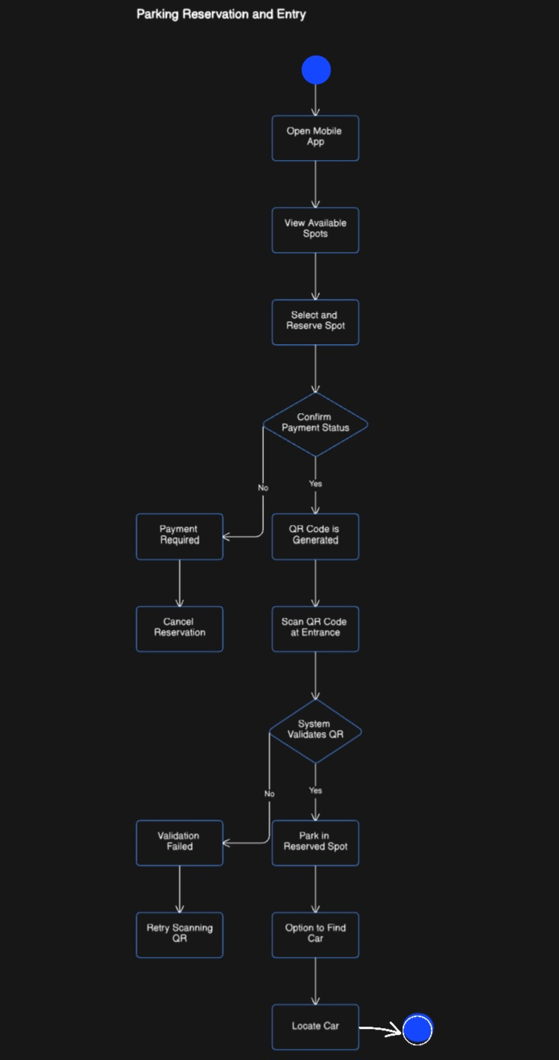
5.4 Activity diagram

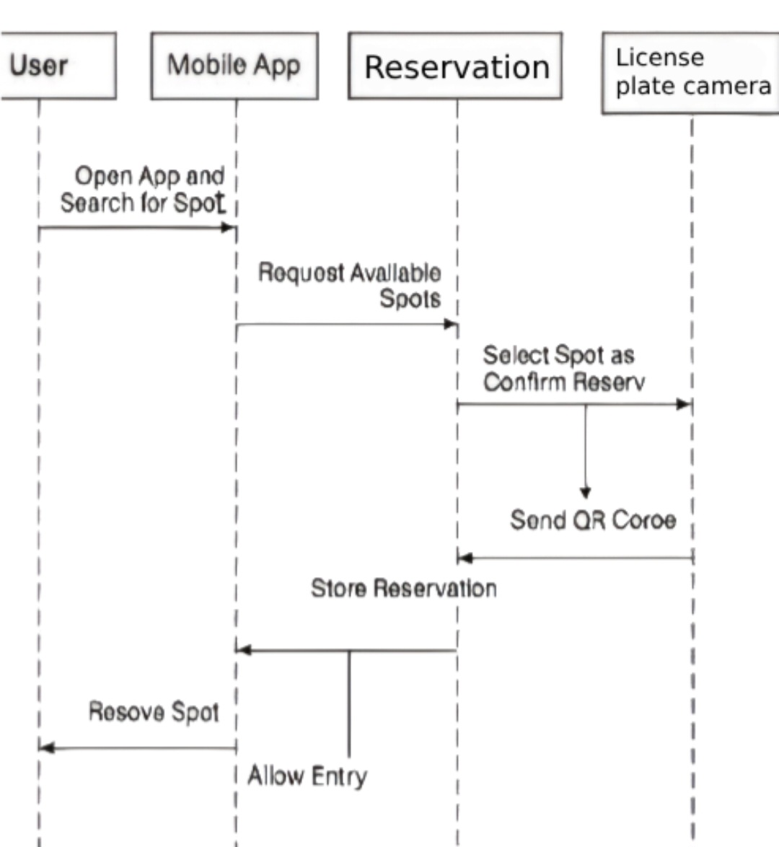
5.5. Sequence Diagram

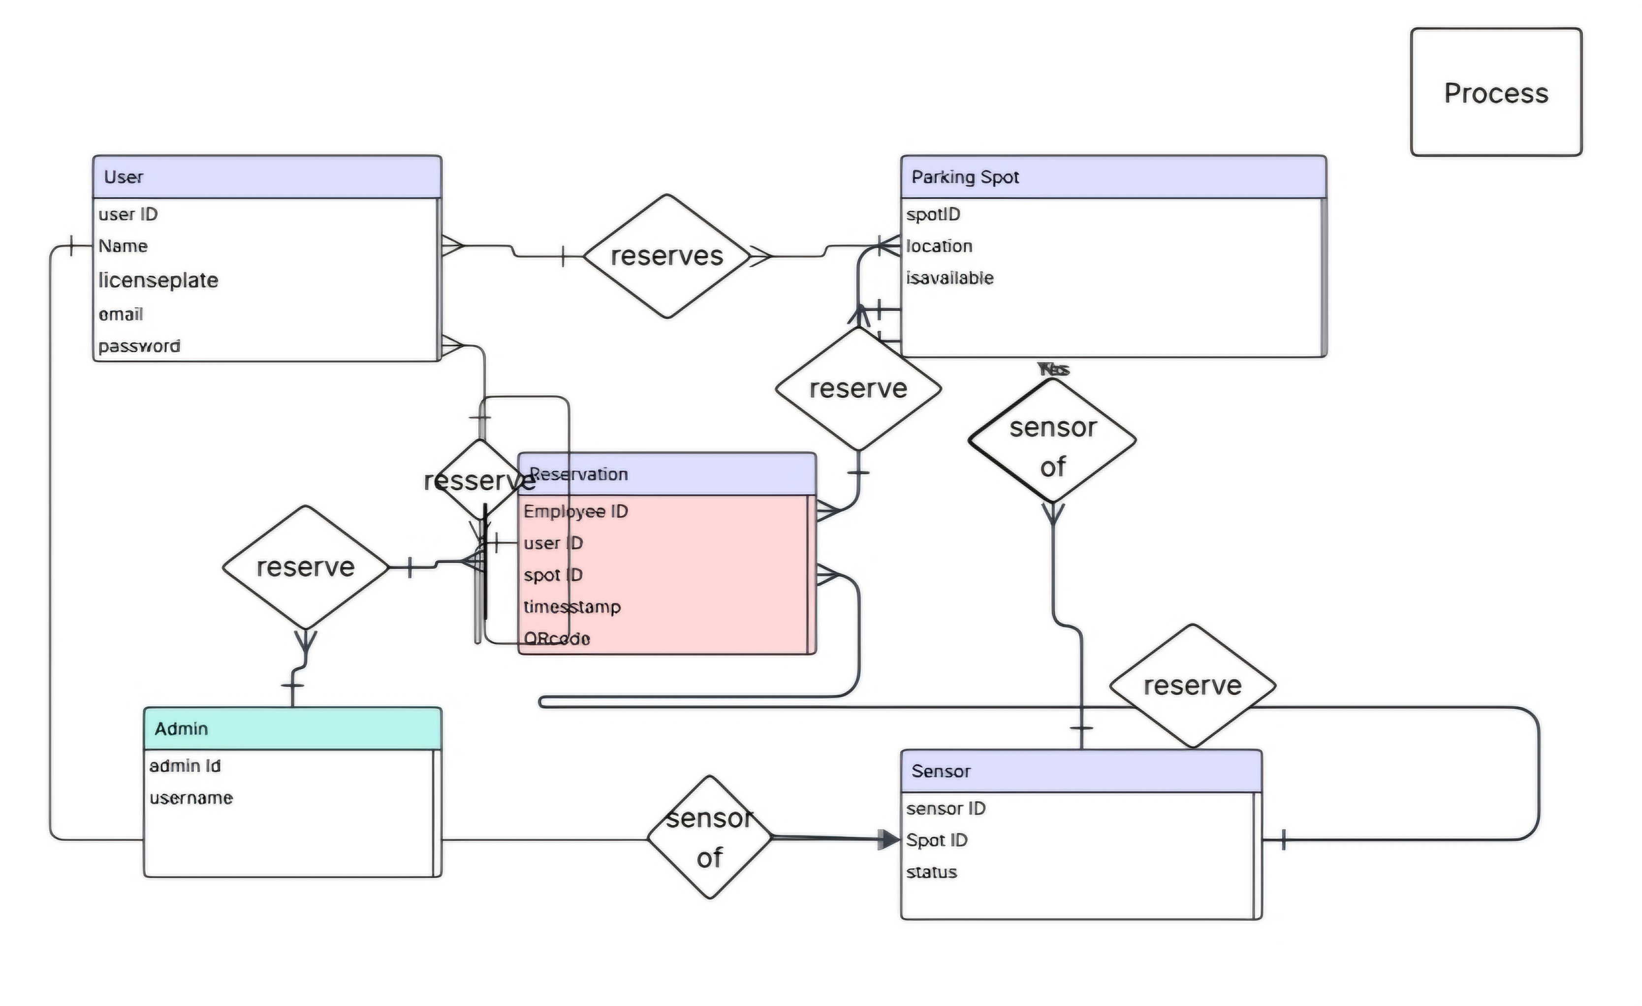
5.6. Entity Relationship Diagram (ERD)

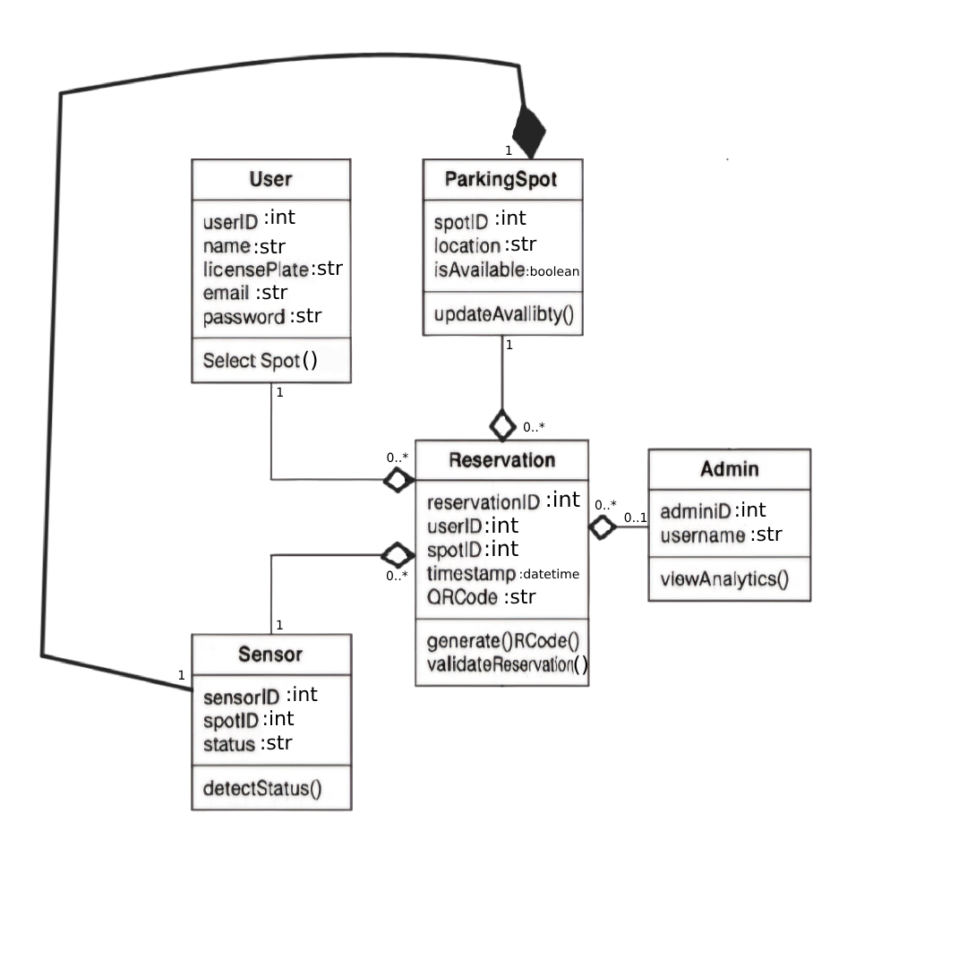
5.7. Class Diagram

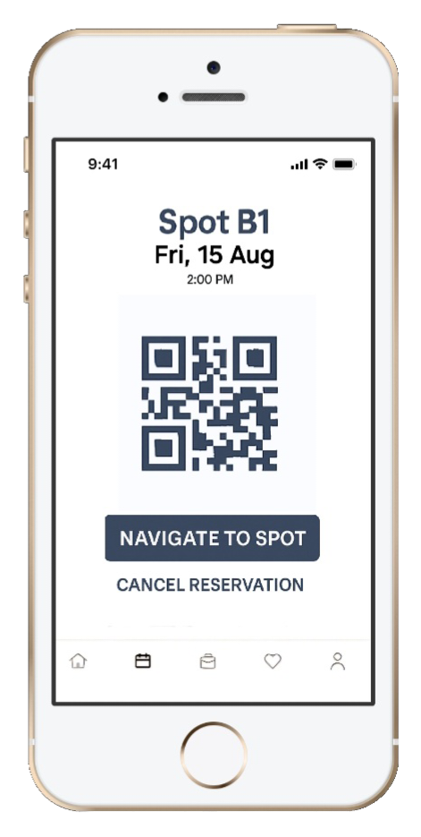
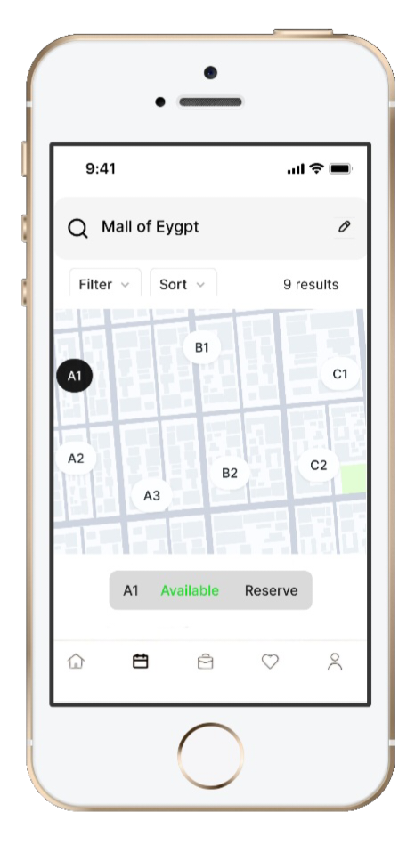
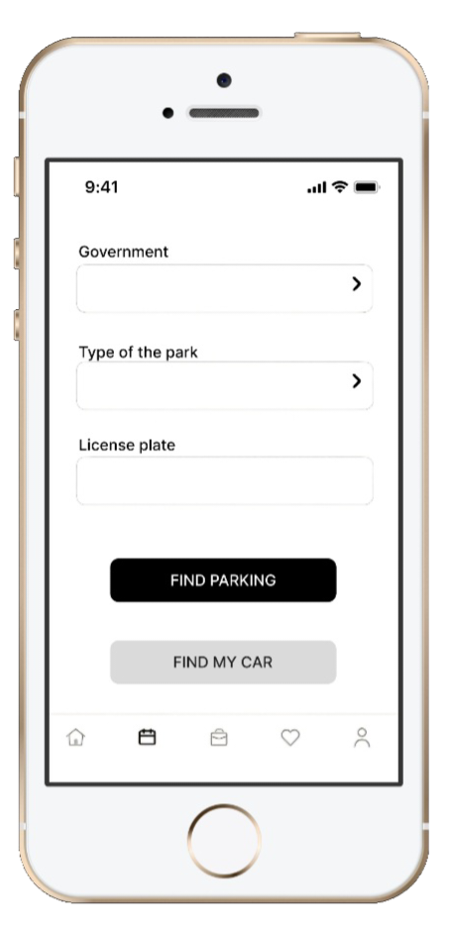
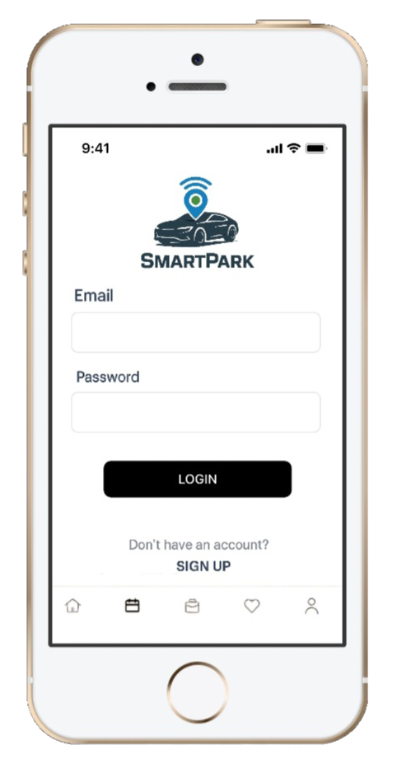
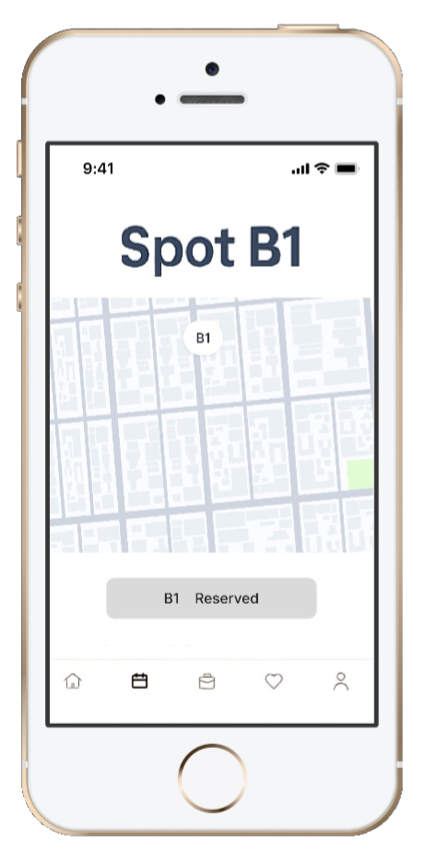
6.1. Design input and output

6.2. Design database and data dictionary
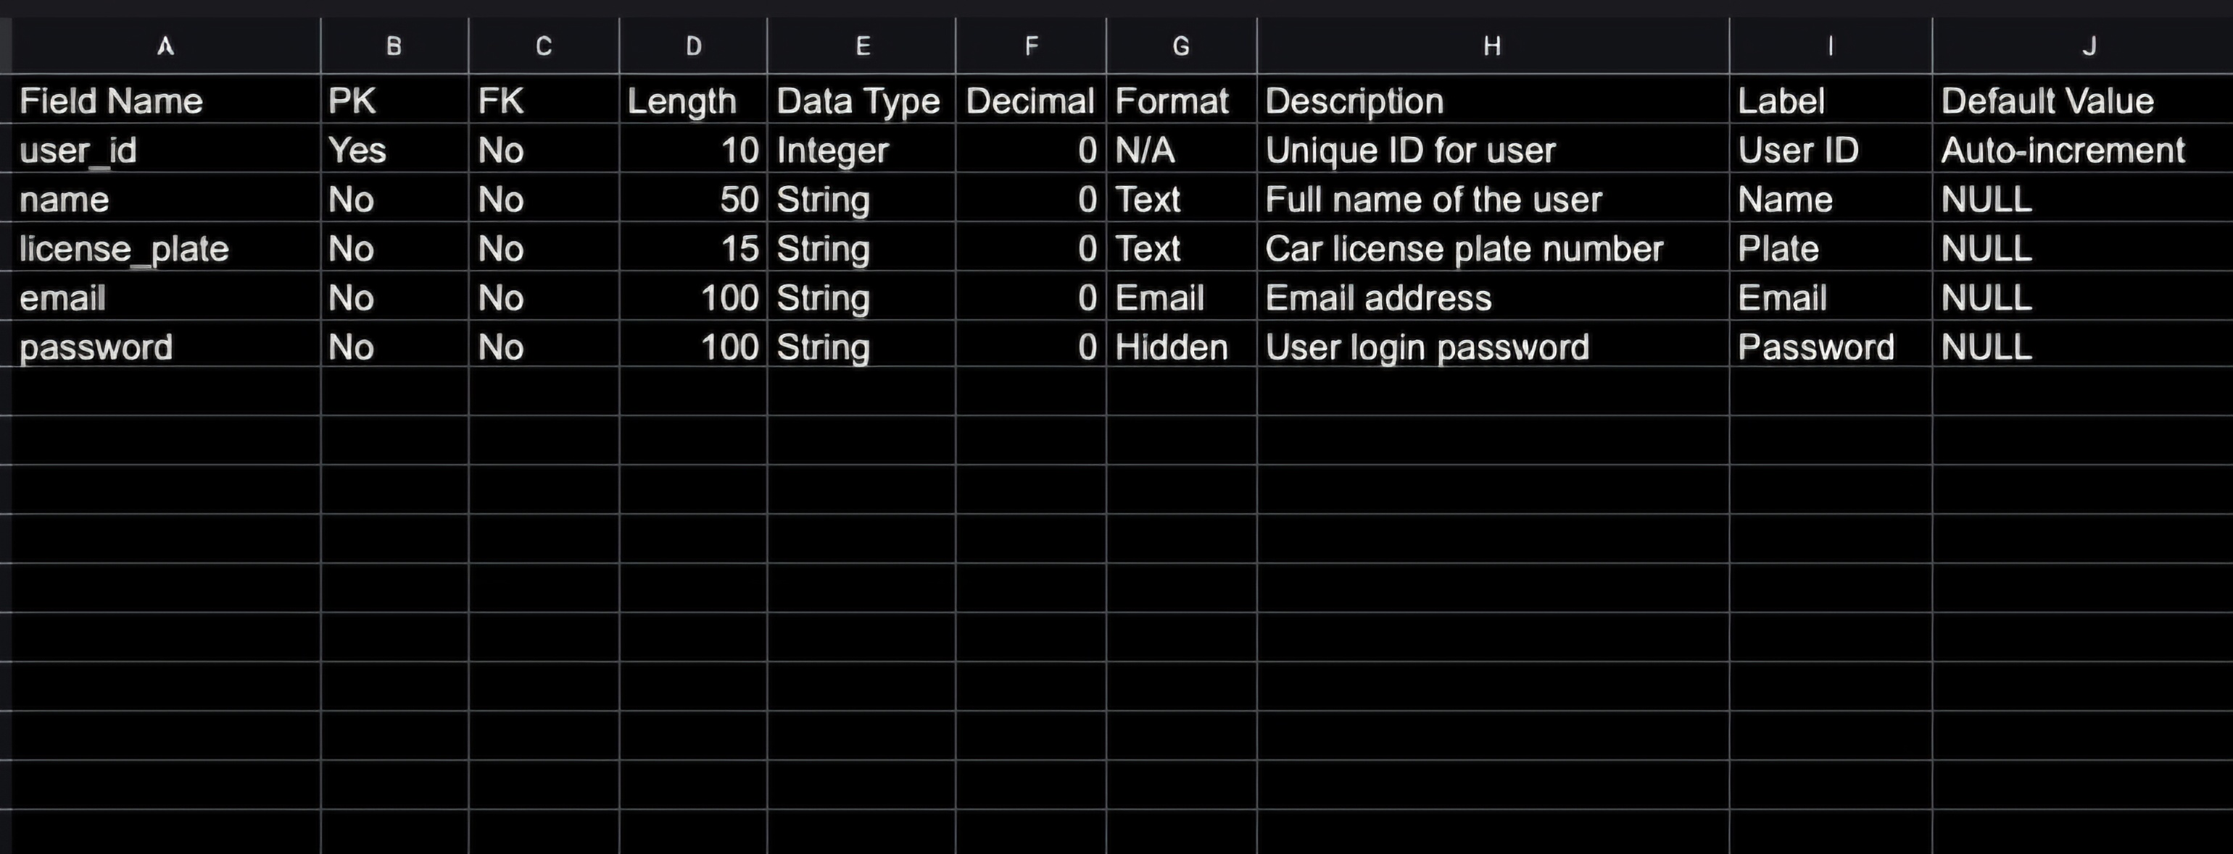
User

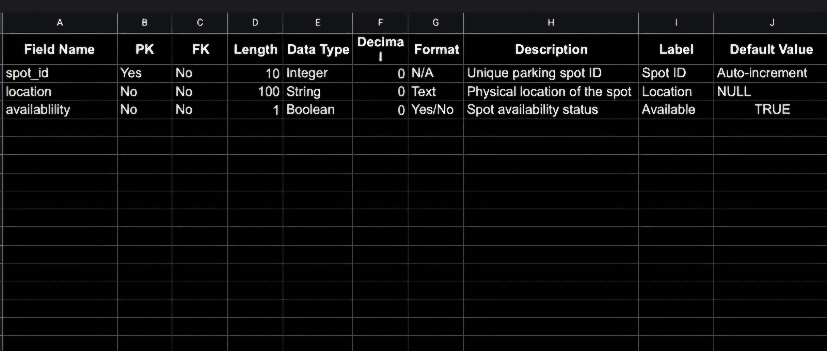
Parking spot

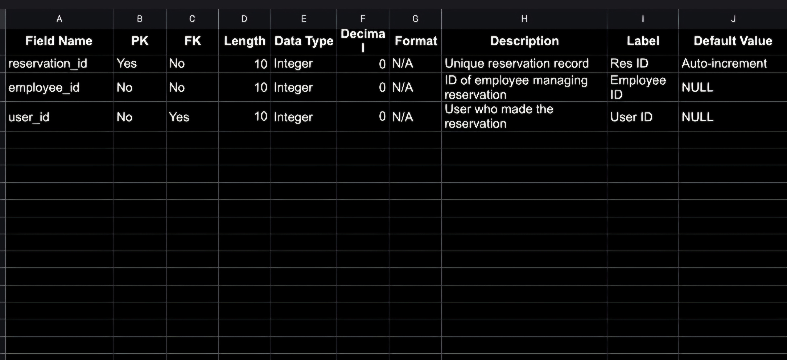
Reservation

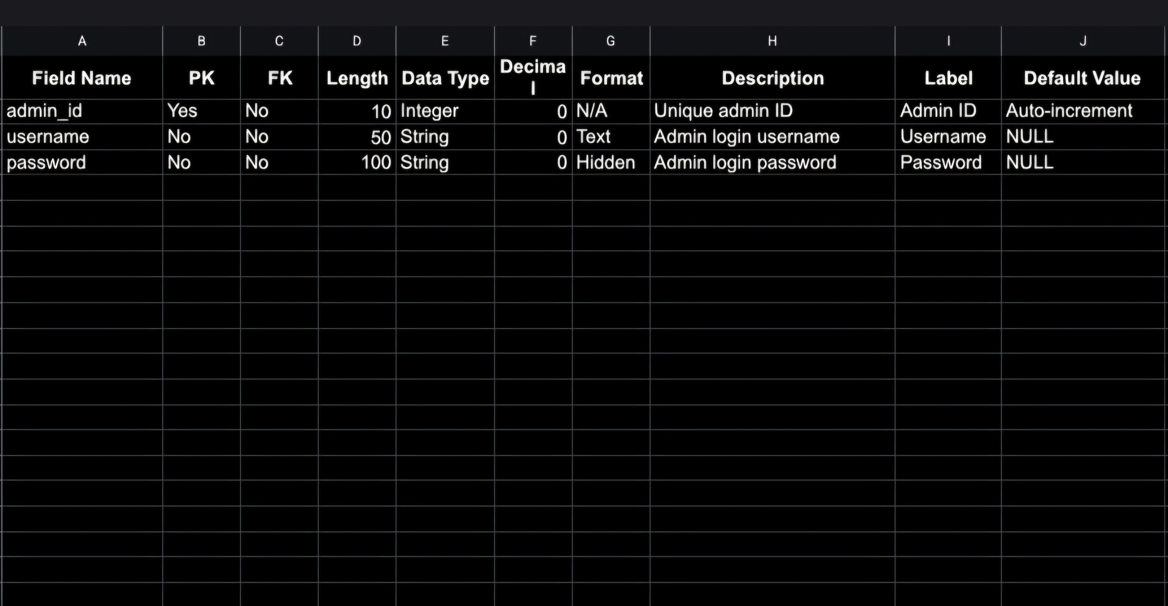
Admin

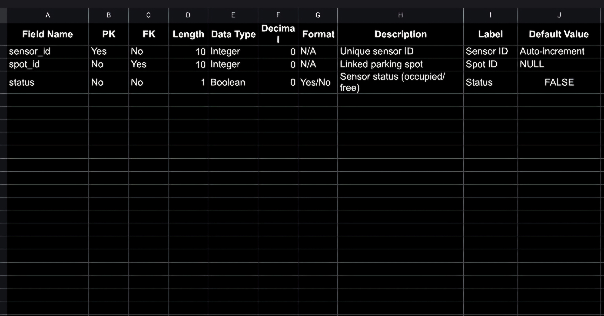
Sensor

